Tip Sheet for Using the Specimen Catalog
(Use Chrome browser for best results)

- The Specimen Catalog is a way to query our current inventory of samples collected since January 2014. To officially request samples for research, a biospecimen request form must be submitted in iLab. Links to iLab and tip sheets are located on the TMSR website.

Specimen Catalog Link: https://osprod.swmed.edu/openspecimen/#/specimen-catalogs/1/dashboard

- Clicking on the link will bring you to this page:
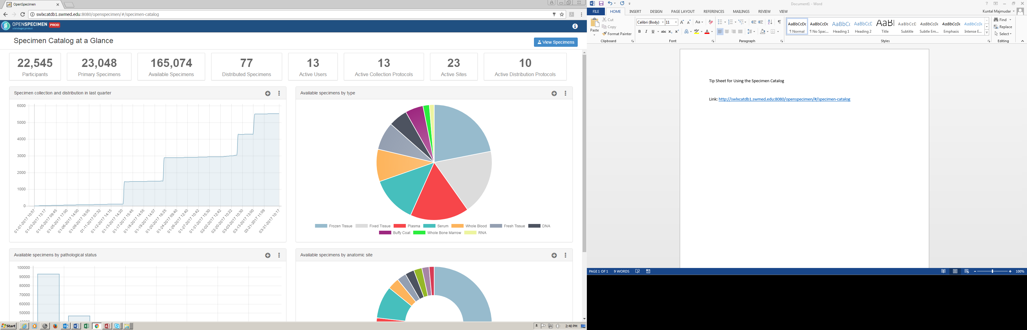

- Click on blue View Catalog icon (top right corner) to reach the Specimen Catalog

- Use the Filters on the left side to identify cases
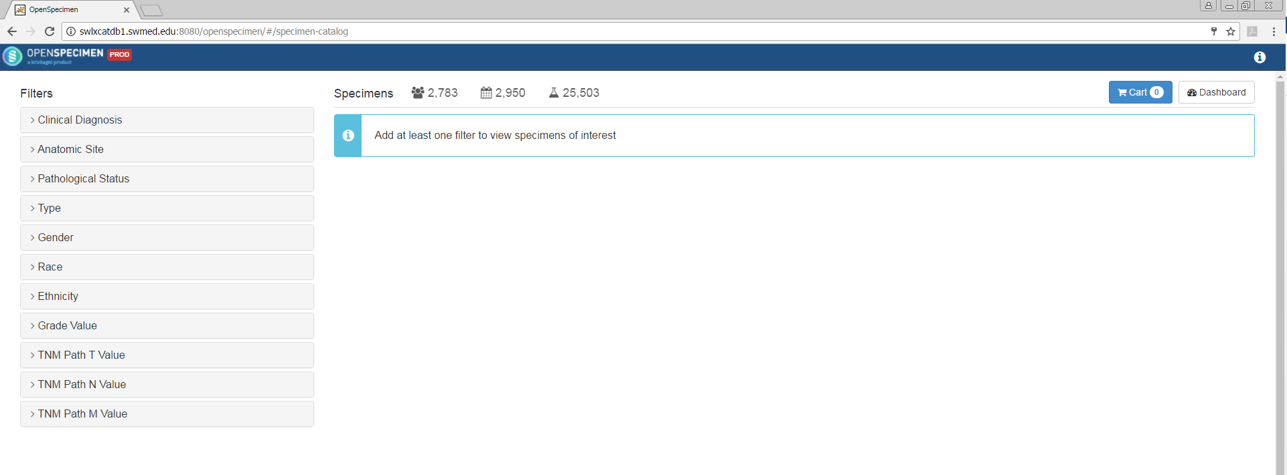
- Click on the Diagnosis filter to see options
You can also type your choice on the Search Filter Value line
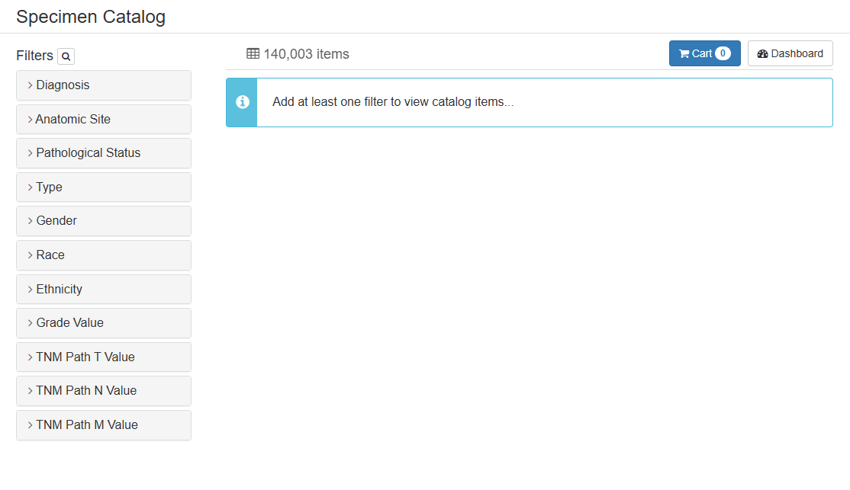

- Similarly, click on the Anatomic Site to see options
You can also type your choice on the Search Filter Value line
- Click on the Pathological Status to see options
Malignant: invasive cancer cases
Malignant, Pre-Invasive: in situ cases
Non-Malignant: non-cancerous (benign) cases
Non-Malignant, Diseased: non-cancerous, but not normal cases
Not Specified: Other

- Click on Type to see options
Body Cavity Fluid: ascites, pleural effusion, cyst fluid, etc.
Buffy Coat
Fixed Tissue: FFPE tissue block
Frozen Tissue: Snap frozen tissue aliquot
Plasma
Serum

- Click on Gender filter to choose between Female and Male patients

- Click on Race filter to select
American Indian or Alaska Native
Asian
Black or African American
Native Hawaiian or Other Pacific Islander
White

- Click on Ethnicity filter to select
Hispanic or Latino
Not Hispanic or Latino

- Click on Grade Value to select tumor registry values for specimens
- Click on TNM Path T Value to select tumor registry values for specimens
- Click on TNM Path N Value to select tumor registry values for specimens
- Click on TNM Path M Value to select tumor registry values for specimens

- If you would like to obtain any specimens, please complete an iLab specimen request form.

